GIT

|  |  |
| --- | --- |
| GIT | GITHUB |
| Git is a software | Github is a service |
| Git can be installed locally on the system | Github is hosted on the Web |
| It does not support user management support | Provides built-in user management |
| Provides a desktop interface called git GUI | Provides a desktop interface Github desktop |

Different types of version control systems

* Local version control systems have a database that stores all file changes under revision control on disc in a special format.
* Centralized version control systems have a single repository, from which each user receives their working copy.
* Distributed version control systems contain multiple repositories, and different users can access each one with their working copy.

### What is GitHub?

   To provide Internet hosting for version control and software development, GitHub makes use of Git.

It helps every team member to work together on the project from anywhere, and makes it easy for them to collaborate

Mention some popular Git hosting services.

* GitHub
* SourceForge
* GitLab
* Bitbucket

### 2. What do you understand by the term ‘Version Control System’?

A version control system (VCS) records all the changes made to a file or set of data, so a specific version may be called later if needed.

This helps ensure that all team members are working on the latest version of the file

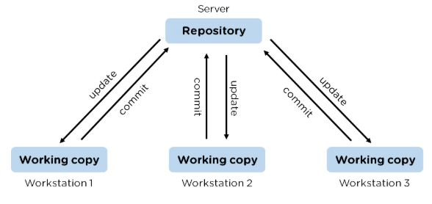

### 1. What is Git?

[Git](https://www.simplilearn.com/tutorials/git-tutorial/what-is-git) is a version control system for tracking changes in computer files and is used to help coordinate work among several people on a project while tracking progress over time. In other words, it’s a tool that facilitates source code management in software development.

Git favors both programmers and non-technical users by keeping track of their project files. It enables multiple users to work together and handles large projects efficiently.

### What do you understand by the term ‘Version Control System’?

A version control system (VCS) records all the changes made to a file or set of data, so a specific version may be called later if needed.

This helps ensure that all team members are working on the latest version of the file



### What is a Git repository?

Git repository refers to a place where all the Git files are stored. These files can either be stored on the local repository or on the remote repository.

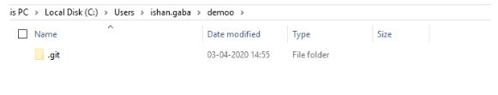

### How can you initialize a repository in Git?

If you want to initialize an empty repository to a directory in Git, you need to enter the git init command. After this command, a hidden .git folder will appear.

### What language is used in Git?

Git is a fast and reliable version control system, and the language that makes this possible is ‘C.’

Using [C language](https://www.simplilearn.com/c-programming-article) reduces the overhead of run times, which are common in high-level languages.

What are the advantages of using Git?

* Faster release cycles
* Easy team collaboration
* Widespread acceptance
* Maintains the integrity of source code
* [Pull requests](https://www.simplilearn.com/tutorials/git-tutorial/git-pull-request)

### What is the correct syntax to add a message to a commit?

 git commit -m "x files created"

### What does the git push command do?

The [Git push command](https://www.simplilearn.com/tutorials/git-tutorial/git-push-command) is used to push the content in a local repository to a remote repository. After a local repository has been modified, a push is executed to share the modifications with remote team members.

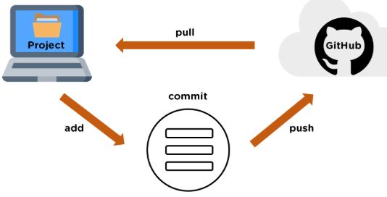

### 18. Difference between git fetch and git pull.

|  |  |
| --- | --- |
| Git Fetch | Git Pull |
| The Git fetch command only downloads new data from a remote repository. | Git pull updates the current HEAD branch with the latest changes from the remote server. |
| It does not integrate any of these new data into your working files. | Downloads new data and integrate it with the current working files. |
| Command - git fetch origin  git fetch --all | Tries to merge remote changes with your local ones.  Command - git pull origin master |

### 19. GitHub, GitLab and Bitbucket are examples of git repository _______ function?

hosting. All the three are services for hosting Git repositories

### 20. What do you understand about the Git merge conflict?

A [Git merge conflict](https://www.simplilearn.com/tutorials/git-tutorial/merge-conflicts-in-git) is an event that occurs when Git is unable to resolve the differences in code between the two commits automatically.

Git is capable of automatically merging the changes only if the commits are on different lines or branches.

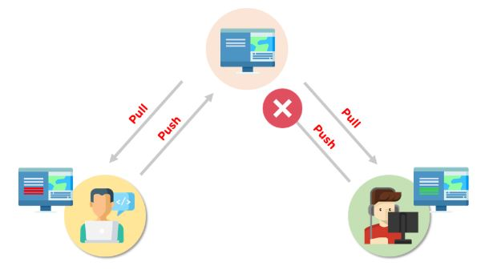

. How do you resolve conflicts in Git?

Here are the steps that will help you resolve conflicts in Git:

* Identify the files responsible for the conflicts.
* Implement the desired changes to the files
* Add the files using the git add command.
* The last step is to commit the changes in the file with the help of the git commit command.

22. What is the functionality of git ls-tree?

The git ls-tree command is used to list the contents of a tree object.

Commonly used Git Command:

Git config🡪Configure the usernme and password

Git init🡪Initialize a local git repository

Git add🡪 Add one or more files to staging area

Git diff🡪View the changes made to the file

Git commit🡪Commit changes to head but not to the remote repository

Git reset🡪Undo local changes to the state of a Git repo

Git status🡪Displays the state of the working directly and staging

Git merge🡪 Merge a branch into an active branch

Git push🡪Upload content from local repository to a remote repository

Git pull🡪 Fetch and download content from a remote repository